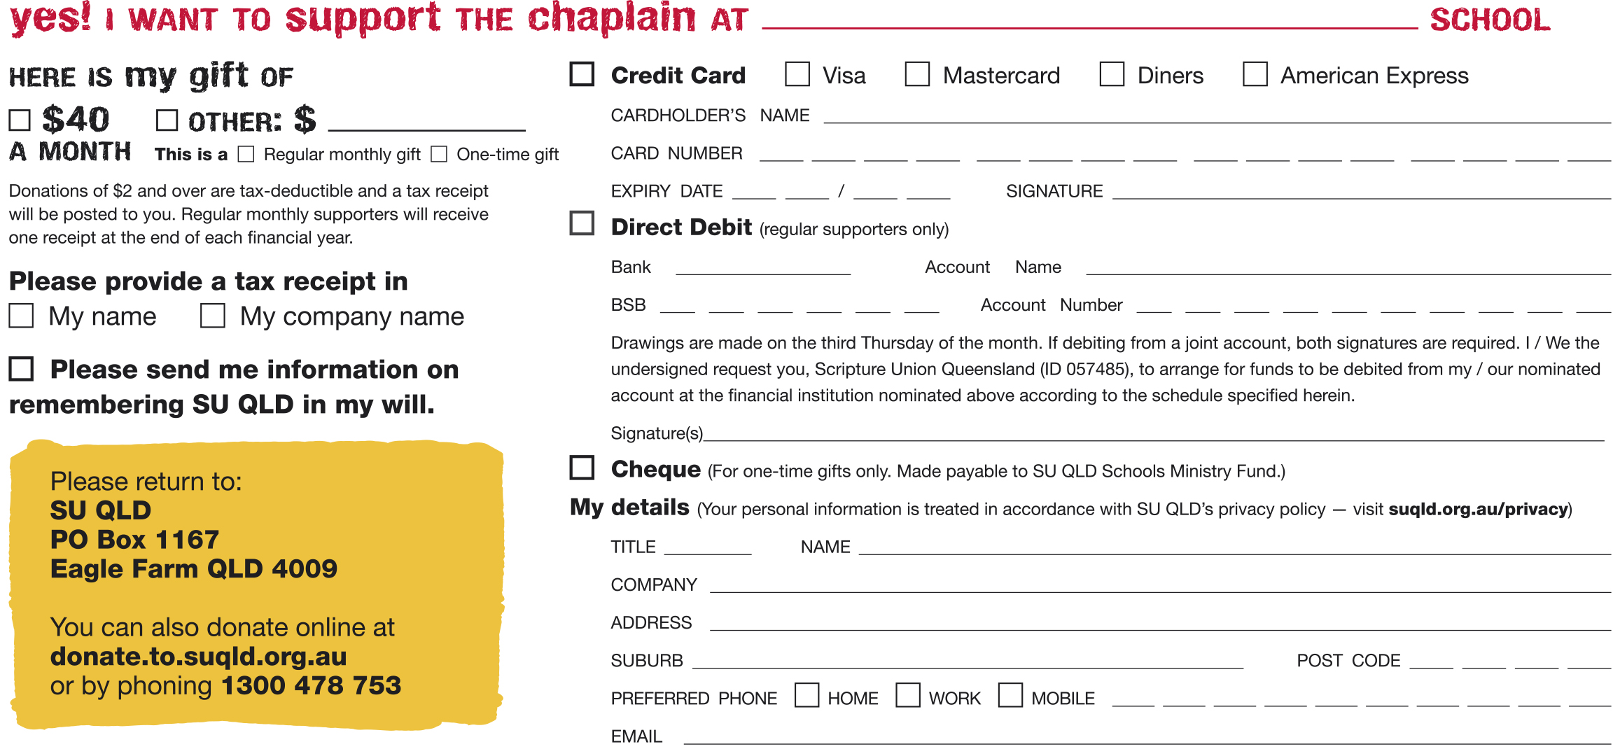
Insert name of your school here

-----------------------------------------------------------------------------------------------------------------------------------
Insert name of your school here

-----------------------------------------------------------------------------------------------------------------------------------
Insert name of your school here

