

Kedron State High School

Situated in the Avenues of Kedron, the school community is flourishing with the current enrolment around 400 students. Students learn and thrive in a supportive small school environment, which aims to maximise the educational outcomes for every student by providing a range of curricular and extracurricular activities.

Home-school partnerships are highly valued to ensure the best possible personal, social and academic outcomes for every child. The vision is to promote learning in students that will take them ‘Beyond the Kedron Fences’ and create lifelong learners.

Leckie Rd

Kedron QLD 4031

**t** 07 3621 3444 f 07 3621 3400

**e** admin@kedronss.eq.edu.au

**kedronss.eq.edu.au**

**You can help by:**• Volunteering to assist at school breakfasts,   
student groups, and other activities / events   
• Offering financial assistance  
• Praying for your school’s chaplaincy activities  
• Holding a fundraising event  
• Being a part of the mentoring program  
**Talk with our chaplain about how you can be involved.**

The partnership between the school and the chaplain, supported by local churches, businesses and community organisations — and in many cases assisted by generous Federal Government funding — provides a network of local support. These positive relationships help children to face issues, and provide hope, connection, meaning, and purpose.

**Kedron**

**State High School**

**Chaplaincy**

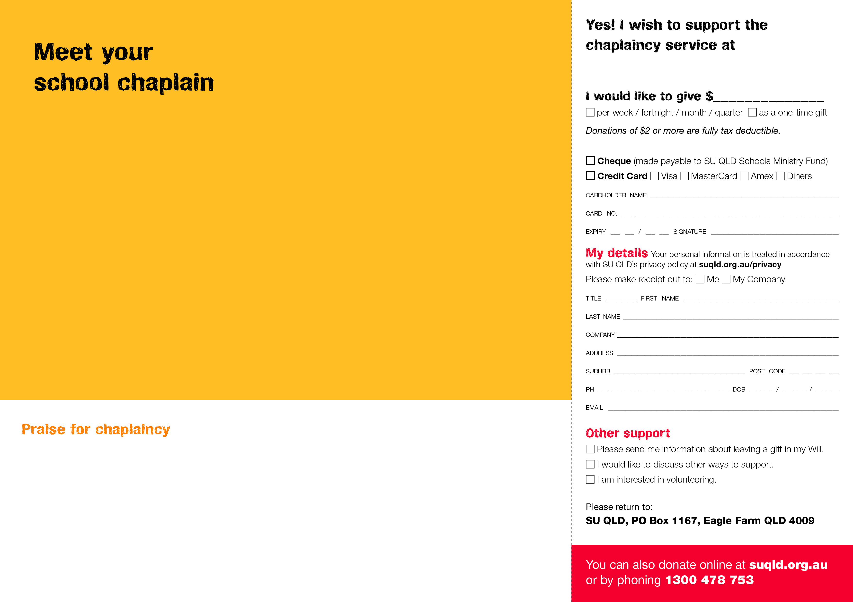

Hi, my name is Leanne Fryer. For more than six years, the Kedron neighbourhood has known me as ‘Chappy Leanne’. Here at school, my life experience in both pastoral care and education, meet together to form my role as school chaplain. I’m here to help build the emotional, social and spiritual health and wellbeing of our school community.

As a team member at Kedron State School, my chaplaincy role adds an extra dimension of support to children in their primary school years. I run programs (like Year 2’s Social Skills program or the “You Can Do It!’ program); I attend the Year 5/6 Camp; I help out in the schoolyard or classroom; and my door is always open for children who need a listening ear.

I enjoy encouraging families and responding to the needs of your children. I welcome your contact at any time when I’m on campus.

You can contact Leanne at   
**leannef@chappy.org.au**

*“The school chaplains who are out there working for you and your community are doing a much tougher job than I ever had to do. We need school chaplains. They are the ‘frontline’ people who are making the difference in our young generation.”*

**— Laurie Lawrence, one of Australia’s  
most successful Olympic swimming coaches**

*“In a situation at school when my kids may need some advice and I can’t be there, enter their school chaplain – a neutral person with good morals who has earned the kids’ trust. It can be the difference between a child making the right and wrong decision.”*

**— Troy Cassar-Daley, Country music legend**

**Kedron State High School**